**Math 101 SYLLABUS**

COURSE NAME: Calculus II- Math 101  
DETAILS: 3 hour lectures, 1 hour lab sections  
TERM: Winter

COURSE DESCRIPTION

Area between curves, techniques of integration. Applications of integration to planar areas and lengths, volumes and masses. First order ordinary differential equations (separable, linear) direction fields, Euler’s method, and applications. Infinite series, power series, Taylor expansions with remainder terms. Polar coordinates. Rectangular, spherical and cylindrical coordinates in 3-dimensional space. Parametric curves in the plane and space: graphing, arc length, curvature; normal binormal, tangent plane in 3-dimensional space. Volumes and surface areas of rotation.

REQUIRED MATERIAL

*Calculus (early Transcendentals*), by James Stewart, eighth edition.

Recommended: Student Solutions Manual.

Access to a hard copy and/or an electronic copy of the textbook is strongly recommended. The two typical

options are:

(1) Purchase one of the hard copy bundles as offered at the University Bookstore, which comes with solution

manual(s) and an access code to Enhanced WebAssign (the online homework system used in this course);

(2) Purchase stand-alone access code to Enhanced WebAssign (this access code includes access to an

electronic version of the textbook).

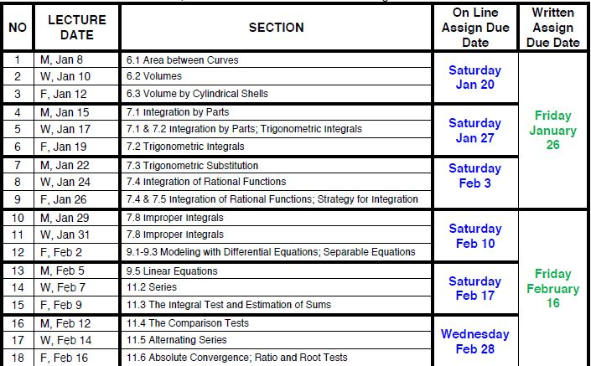LECTURE CONTENT

LECTURE CONTENT CON’T

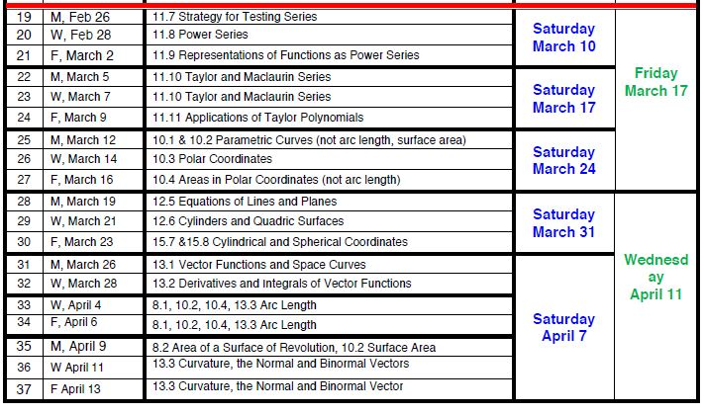

LAB CONTENT

There is a weekly 50-minute lab period, and there will be a 20-minute quiz in each laboratory class.

In order to help you prepare for the quiz, a list of problems will be posted on the class web page. You are

strongly encouraged to do as many of these problems as possible before going to the lab. The lab instructor

will assist you during the first 30 minutes of the lab with any difficulties you may have encountered with

these problems. I cannot over emphasize the importance of your knowing how to do the problems before

going to the lab. There will not be enough time for the lab instructor to provide assistance with all of the

problems during the lab. The lowest graded quiz will not be counted.