**MatE 202 SYLLABUS**

COURSE NAME: Materials Science II – MatE 202  
DETAILS: 3 hour lectures, 3/2 lab sections  
TERM: Fall

COURSE DESCRIPTION

3.00 Units (3-0-3/2). An introduction to the science of materials relating their mechanical, thermal, electronic and chemical properties to atomic, molecular and crystal structure. Ceramic and metallic crystals, glasses, polymers and composite materials. Multi-phase materials, strengthening processes. Laboratories include mechanical properties of metals and polymers, microstructure, heat treatment of steel. Credit may not be obtained in this course if previous credit has been obtained in MAT E 252. Prerequisite: CHEM 105 or consent of Department.

REQUIRED MATERIAL

“Materials Science and Engineering, An Introduction”, 8th, 9th or 10th Ed., by W.D. Callister Jr., John Wiley & Sons.

Lab Manual & Kit from U of A Bookstore

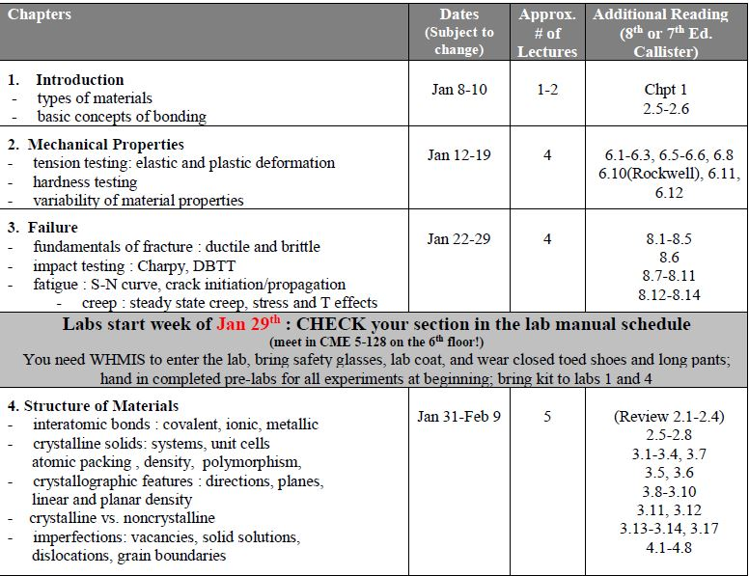LECTURE CONTENT

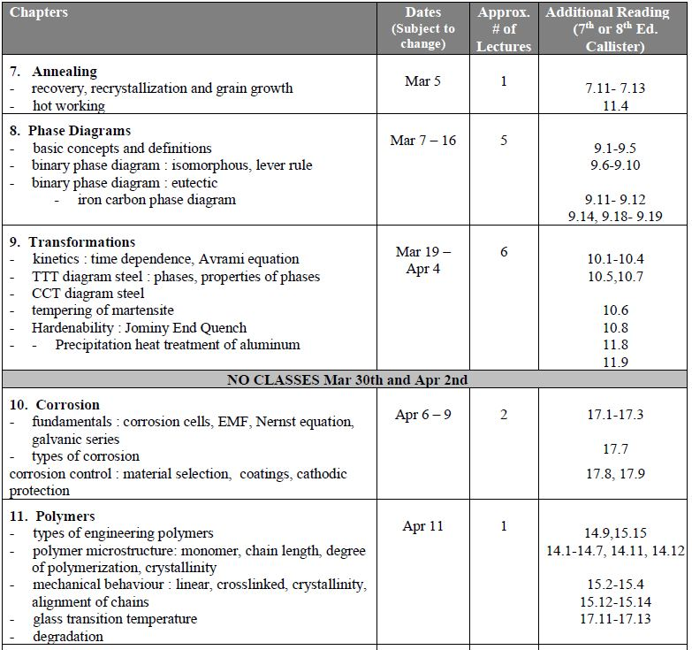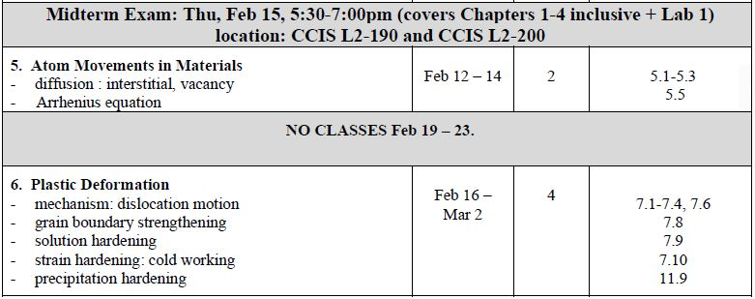

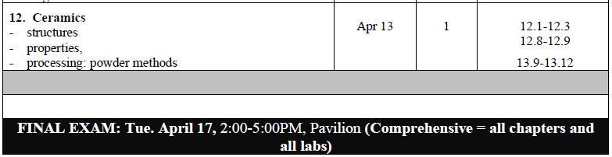

LAB CONTENT

Lab attendance, for the full duration, is mandatory, and **you must attend the section in which you are**

**registered**. Unless permission has been granted in advance you will receive a grade of zero if you attend

an incorrect lab section.

Each lab session will consist of multiple experiments so be sure to ***do the pre-lab portion of each***

***experiment on a separate piece of engineering paper to hand in at the beginning of each lab sessi*on*!***

Labs must be completed and handed in at the end of each lab period so bring your lab manual to the lab.

All morning labs start at **8:00 AM** and all afternoon labs begin at **2:00 PM.**

**\*\*\*REPORT TO CME 5-128 (6th floor) at the beginning of EACH lab session.\*\*\***