**Engg 160 SYLLABUS**

COURSE NAME: Introduction to Engineering Design, Communication, and Profession- Engg 160  
DETAILS: 1 hour lectures, 2/1 hour lab sections  
TERM: Winter

COURSE DESCRIPTION

*2 (fi 4) (1-0-2) Fundamental design process; communication; teamwork; the engineering disciplines, career fields; professional responsibilities of the engineer including elements of ethics, equity, concepts of sustainable development and environmental stewardship, public and worker safety and health considerations including the context of the Alberta Occupational Health and Safety Act. Co-requisite ENGL 199.

1. **Introduction to Engineering Design**: the general design process, design stages with special emphasis on planning, problem definition, customer needs, concept generation and selection, decision-making, engineering tools, and design examples from various disciplines.
2. **Communication in Engineering**: key principles of communication, teamwork, various technical drawings, sketching tools, presentations, and technical writing.
3. **Introduction to Engineering Profession**: purposes of engineering, professionalism, public and workplace safety, codes of ethics, sustainability, regulatory requirements, creativity, research, and project management.

REQUIRED MATERIAL

**MANDATORY TEXT: Designing Engineers: An Introductory Text** – McCagan, Anderson, Kortschot, Weiss, Woodhouse (Wiley). Available online: <https://books.google.ca/books/about/Designing_Engineers_An_Introductory_Text.html?id=dgTYBgAAQBAJ&redir_esc=y>

**Recommended (but not mandatory) Text: Introduction to Professional Engineering in Canada** 5th ed. – G.C. Andrews, J.D. Aplevich, R.A. Fraser, C.G. MacGregor (Pearson). Available online: <https://www.vitalsource.com/en-ca/products/introduction-to-professional-engineering-in-gordon-c-andrews-v9780135240137>

**Software Requirements:** MS Office or equivalent, MS Visio or equivalent, Adobe reader and any free video maker. Students have a choice of what software they would like to use. It is recommended to use a free video editing software or a free trial of a paid software. If student decides to purchase the software, it is at their discretion only. This course DOES NOT require students to purchase any particular video editing software. If students still choose to purchase a software, some student discounts may be applicable to students in some companies. Other software can be found at <https://ualberta.onthehub.com/WebStore/>

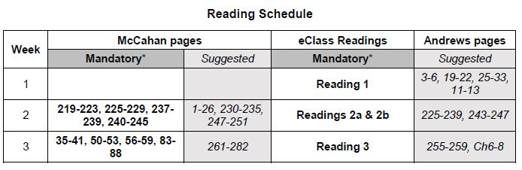LECTURE CONTENT

READING SCHEDULE CON’T

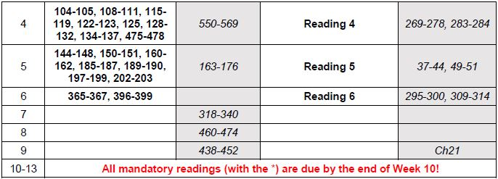

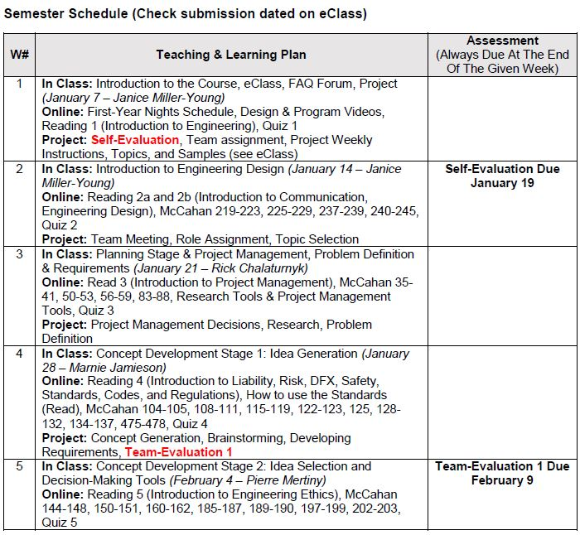

SEMESTER SCHEDULE CON’T

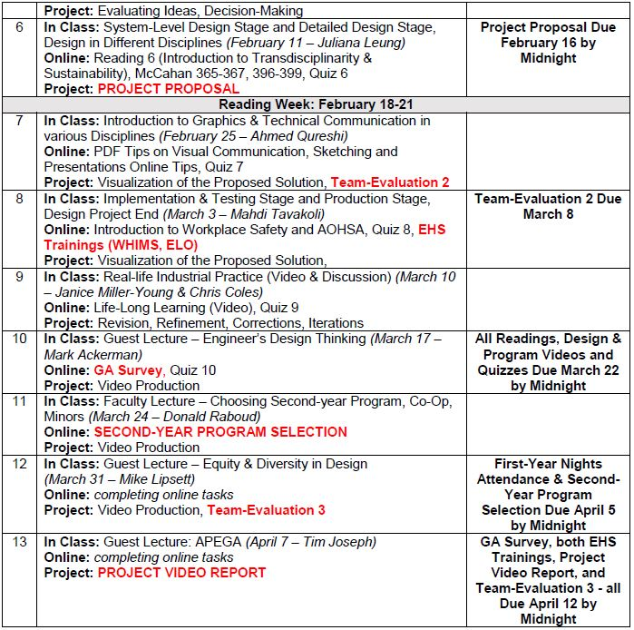

LAB CONTENT

No lab content found in syllabus.