**Chem 105 SYLLABUS**

COURSE NAME: Introductory University Chemistry II- Chem 105  
DETAILS: 3 hour lectures, 3/2 lab sections  
TERM: Winter

COURSE DESCRIPTION

You will learn some basic principles that influence the spontaneity, rate, extent and direction of a chemical reaction. Applying these principles to logically solve chemical problems should lead to a better understanding of the role chemistry has in our lives and to be able to think critically about chemical issues.

Chem 102/105 is the second course of the introductory chemistry courses. The prerequisite is Chem 101/103.

REQUIRED MATERIAL

1. Chem 102/105 course website (eClass): <https://eclass.srv.ualberta.ca>

Course notes, grades, supplementary materials, useful resources and class announcements can be all found on the eClass. Students are strongly encouraged to check the course site regularly.

1. Silberberg & Amateis, Chemistry, 7th edition, McGraw Hill, 2014
2. Introductory University Chemistry II Laboratory Manual (Chem 102/105), 2017-208 Ed.
3. Safety glasses, lab coat, covered footwear, long pants for the laboratory.

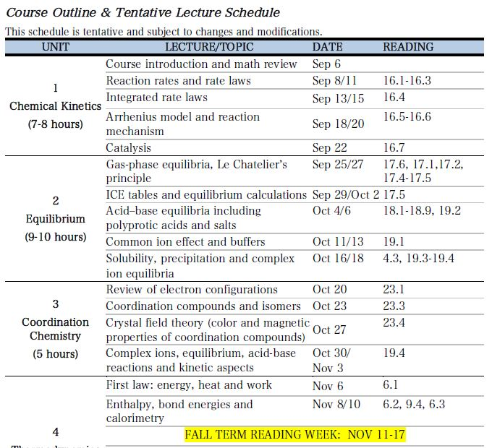LECTURE CONTENT

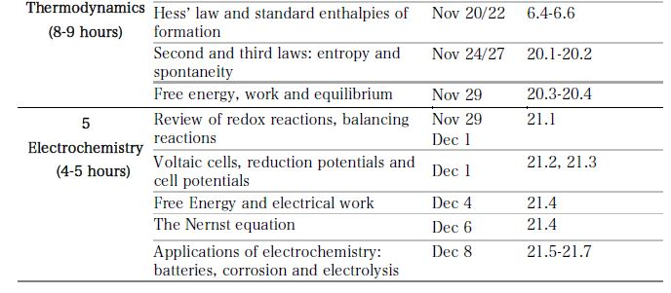

LAB CONTENT

* You must register in, attend, and complete the laboratory portion of the course.
* Read the instructions in the manual before the first lab, which includes check-in (bring ID, safety glasses, and a lab coat are mandatory. You must comply with other laboratory regulations as specific in the laboratory manual.