**CIV E 240 SYLLABUS**

COURSE NAME: Technical Communications- CIV E 240  
DETAILS: 1 hour lectures, 2/1 hours Seminar   
TERM: Winter

COURSE DESCRIPTION

*2 (fi 8) (second term, 1-2S-0) Written and oral communications in civil engineering; lectures and practice on

presentation of oral and written reports, including technical proposals; progress reports; field inspection

reports; consulting reports; and coverage of elements of ethics, equity, concepts of sustainable development

and environmental stewardship, public and worker safety and health considerations including the context of

the Alberta Occupational Health and Safety Act. Seminars and practice in developing effective search

strategies for technical information. A written report must be submitted by each student.

The objectives of this course are to provide an introduction to solving civil and environmental engineering

problems and communicating the findings. Specifically, students will be introduced to:

1. Aspects of engineering design -- including problem formulation, problem solving, optimization, and

making decisions and/or recommendations.

1. Solving engineering problems encompassing several discipline areas: geotechnical, water resources,

structural, construction, transportation, and environmental engineering.

1. Reporting and communicating the technical findings using proposals, technical memorandums, oral

presentations, and formal technical reports.

REQUIRED MATERIAL

**Text and References (Mandatory):**

- Readings will be available on eClass.

- Your writing is a required text in this course. For many assignments and activities, I will ask you to read

over work that you have already written.

- Your classmates’ writing in a required text in this course. For many assignments, you will read and provide

feedback on each other’s work.

- To be able to participate in this course, you need to bring your own laptop/tablet. If you do not own one,

you can borrow it from the library: <https://www.library.ualberta.ca/services/equipment-lending>.

**Text and References (Recommended):**

Nadasdi, Terry, and Stéfan Sinclair. SpellCheckPlusPro. Nadaclair Language and Technologies, 2012.

Web. http://pro.spellcheckplus.com/. (I recommend that you use this online software program on every final

draft in this course. It will assist you to check your spelling and grammar although you will want to proofread

carefully, as well). A subscription costs $14.99 a year, but as a U of A student, you can receive a special

rate of $30 for four years. Access this discount at http://pro.spellcheckplus.com/promo/?pcode=uofa4.)

You are asked to bring your laptop to work in class; I also strongly recommend bringing a USB flash drive to

every class to save any work you create during the class period (or you can save your work on Google

Drive).

LECTURE CONTENT

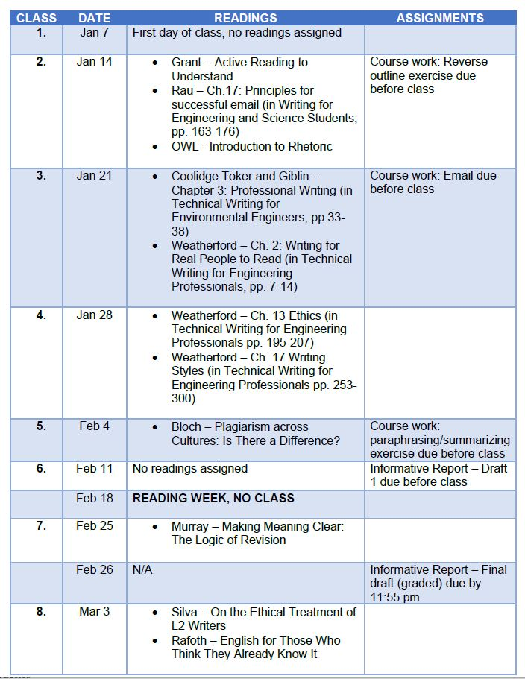

LECTURE CONTENT CON’T

