**CIV E 419 SYLLABUS**

COURSE NAME: Transportation Engineering: Highway Planning & Design- CIV E 419  
DETAILS: 3 hour lectures, 3/1 hour Lab   
TERM: Winter

COURSE DESCRIPTION

This course is designed to provide students an opportunity to apply the structured approach of problem-solving, covered in your previous Transportation Engineering courses, to a specific design problem, and to further develop design, presentation, report writing, project management and technical problem solving skills. Through this course, you will learn

1. how to analyze problems scientifically,
2. how to search for related information from different sources,
3. how to apply appropriate techniques to establish a solution mechanism,
4. how to evaluate the worth of possible solutions.

REQUIRED MATERIAL

* Notes on related topics such as Highway Capacity and Level of Service, safety audits, etc., as required will be handed out in class.
* Highway Geometric Design Guide (1995) by Alberta Transportation. [Updated to 1999].
* All relevant course materials will be posted at eClass.
* Suggested references:
  + Geometric Design Guide for Canadian Roads (2011) by the Transportation Association of Canada.
  + A Policy on Geometric Design of Highway and Streets (2011) by the American Association of State Highway and Transportation Officials.
  + Ortuzar, J. D. and L. G. Willumsen, Modelling Transport, 4th Edition, Jon Wiley&Sons, Inc. 2011
  + Hauer, E. The Art of Regression Modeling in Road Safety (2015), Springer International Publishing

LECTURE CONTENT

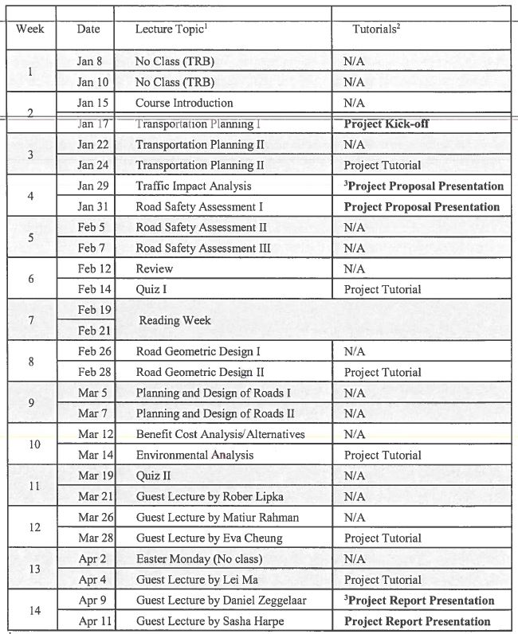

LAB CONTENT

No lab content found in syllabus.