**CIV E 409 SYLLABUS**

COURSE NAME: Construction Methods- CIV E 409  
DETAILS: 3 hour lectures, 3/1 hour Lab   
TERM: Winter

COURSE DESCRIPTION

*4.5 (ti 8) (either term, 3-0-3) Principles of building, heavy and bridge construction; wood and formwork design, stability during construction, economics of equipment selection, movement of material on construction sites, safety, and constructability issues. Students work in teams on a design project.

REQUIRED MATERIAL

Peurifoy R. L. and Ledbetter W. B. 2006, "Construction Planning Equipment and Methods", Eighth Edition, McGraw-Hill, Inc. N. Y. (ISBN 9780073401126) however seventh edition is also acceptable

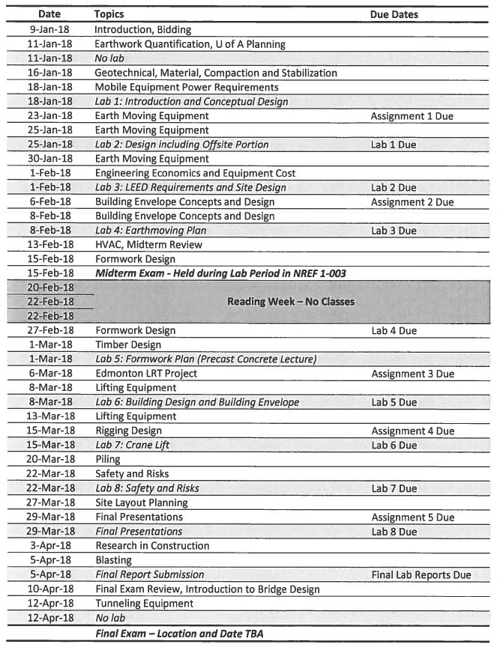LECTURE CONTENT



LAB CONTENT

|  |  |
| --- | --- |
| **Lab Topic** | **Date** |
| Lab 1: Introduction and Conceptual Design | 2018-01-18 |
| Lab 2: Design including Offsite Portion | 2018-01-25 |
| Lab 3: LEED Requirements and Site Design | 2018-02-01 |
| Lab 4: Earthmoving Plan | 2018-02-08 |
| Lab 5: Formwork Plan | 2018-03-01 |
| Lab 6: Building Design and Building Envelope | 2018-03-08 |
| Lab 7: Crane Lift | 2018-03-15 |
| Lab 8: Safety and Risks | 2018-03-22 |
| Lab 9: Final Presentations | 2018-03-29 |
| Lab 10: Final Report Submission | 2018-04-05 |