**CIV E 295 SYLLABUS**

COURSE NAME: Numerical Methods for Civil Engineers- CIV E 295  
DETAILS: 3 hour lectures, 2/1 hours Lab sections   
TERM: Winter

COURSE DESCRIPTION

*4 (fi 8) (second term, 3-0-2) Application of numerical methods to civil engineering problems.

- Introduce concepts and procedures for computational modelling of Civil Engineering problems. In

particular, learn about the problems that require numerical methods to find their solutions.

- Learn the following about numerical methods for solving quantitative problems in Civil and Environmental

Engineering:

o Applicability of the method

o Why and when a method works.

- Practice and further develop computer implementation skills. The computational platform will be

Mathematica.

REQUIRED MATERIAL

sameradeeb.srv.ualberta.ca

labs: <https://www.youtube.com/playlist?list=PLWlJvChadvVwSrn6irdxZ_TwTuz5A6DtW>

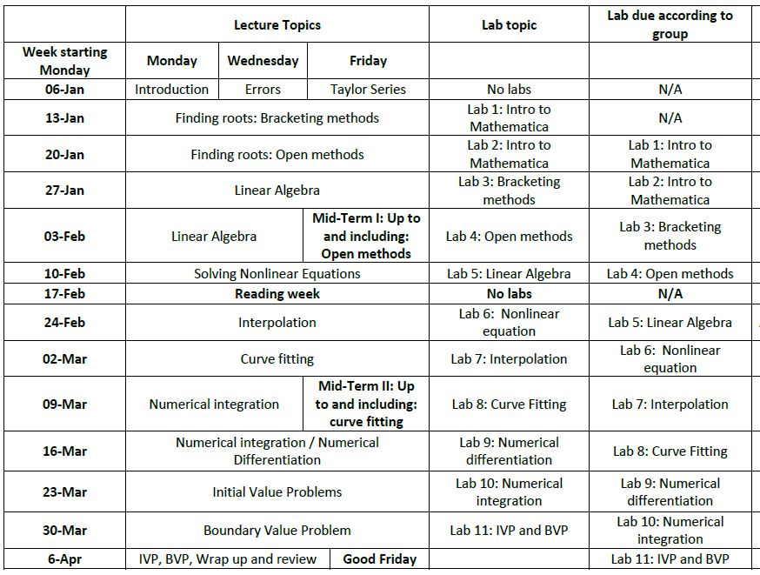LECTURE/ LAB CONTENT