**CIV E 265 SYLLABUS**

COURSE NAME: Engineering Drawing and Computer Graphics- CIV E 265  
DETAILS: 2 hour lectures, 3/1 hour lab sections  
TERM: Fall

COURSE DESCRIPTION

*3.5 (fi 8) (either term, 2-0-3) Multiview representation, pictorial views of three-dimensional objects.

Computer-aided graphics using AutoCAD.

1. Understand the principles and conventions used in technical shape description

2. Be able to produce orthographic drawings of three dimensional objects

3. Be able to produce pictorial sketches of three dimensional objects

4. Have enhanced visualization skills

5. Be able to solve simple graphical civil engineering problems

6. Become proficient in the use of AutoCAD

7. Appreciate how graphical communication skills relate to engineering design

REQUIRED MATERIAL

(Mandatory)   
A Tutorial Guide to AutoCAD 2020 Lockhart  
A Tutorial Guide to AutoCAD 2019 Lockhart (acceptable)

(Recommended)  
McAdam & Winn: Engineering Graphics  
Any introductory Engineering Graphics text

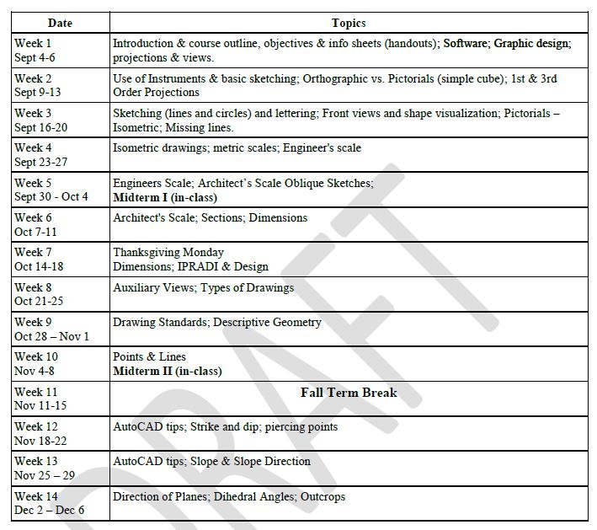LECTURE CONTENT

LECTURE CONTENT CON’T



LAB CONTENT

