**CIV E 250 SYLLABUS**

COURSE NAME: Plane Surveying- CIV E 250  
DETAILS: 3 hour lectures, 3/1 hours Lab sections   
TERM: Winter

COURSE DESCRIPTION

*4.5 (fi 8) (either term or Spring/Summer, 3-0-3) Basic surveying concepts and instrumentation,

measurement errors, coordinate systems, leveling, traversing, layout surveys, earthwork volumes,

conventional, and digital mapping, GIS concepts, aerial photography, and GPS.

**Course Objectives & General Content:**

1. To develop an understanding of basic concepts and computational procedures used in plane surveying

2. To estimate the accuracy of surveying that you may conduct or have conducted for you

3. To provide an overview of engineering interaction with surveying

REQUIRED MATERIAL

Elementary Surveying: An Introduction to Geomatics 15ed Loose Leaf version

Software:

WolfPack (Windows only; available in NREF computer labs)

QuikGrid (Windows only; available in NREF computer labs)

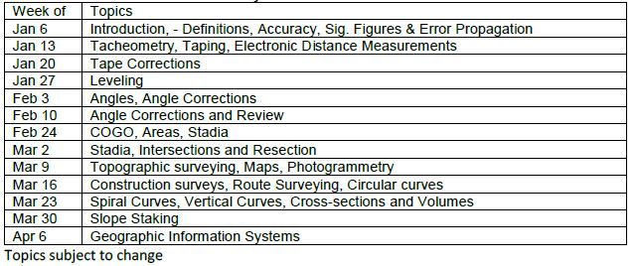LECTURE CONTENT

LAB CONTENT

