**CIV E 221 SYLLABUS**

COURSE NAME: Environmental Engineering Fundamentals- CIV E 221  
DETAILS: 3 hour lectures, 3/2 lab sections  
TERM: Winter

COURSE DESCRIPTION

*3.8 (fi 8) (second term, 3-0-3/2) Basic mechanisms of chemistry, biology, and physics relevant to environmental engineering processes. Principles of equilibrium reactions and kinetics, mass transfer and material balances, microbial growth and kinetics, water, energy, and nutrient cycles. Applications to environmental engineering systems as biological degradation, mass and energy movement through the environment, and design of water and wastewater treatment systems.

The overall objective of this course is to introduce the students to the interdisciplinary study of the

environment. As future working engineers, it is not enough for you to understand the causes and effects of

environmental problems in qualitative terms only. You must also be able to express the perceived problem

and its potential solution in quantitative terms. To do this, you must be able to draw on the basic sciences

such as chemistry, physics, microbiology, ecology, climatology, hydrology and others to predict the fate of

pollutants in the environment and to design effective treatment systems to reduce impacts.

The objectives of this course, your first course in Environmental Engineering, are to:

1. Investigate the causes and mitigation of environmental problems;

2. Review or introduce basic scientific knowledge necessary to understand the nature of environmental

problems and to be able to quantify them so you can practically apply this knowledge to basic environmental

design and assessment tasks;

3. Introduce control techniques (water and wastewater treatment plant design, for example) and develop

simple pollutant transport and fate models;

4. Demonstrate environmental engineering measurements and principles in the laboratory and highlight the

importance of the laboratory studies in the environmental engineering practice;

5. Outline the engineer’s role in the protection of the environment and public health.

Achieving the objectives will give you an accurate impression of the work environmental engineers do,

prepare you for the next higher level of environmental engineering courses and give you some basic tools to

use in your summer or co-op jobs.

REQUIRED MATERIAL

Davis, M.L. and Masten, S.J. Principles of Environmental Engineering and Sciences. (2020). Fourth Edition,

McGraw-Hill, Inc., New York, NY.

LECTURE CONTENT (next page)

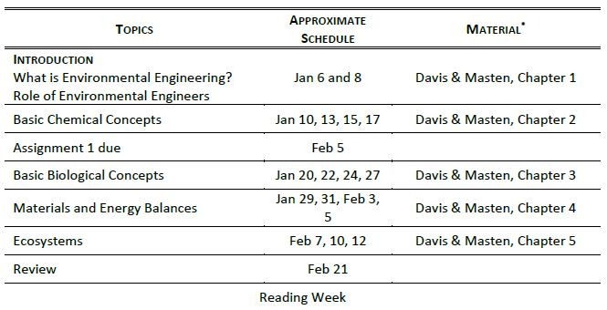LECTURE CONTENT

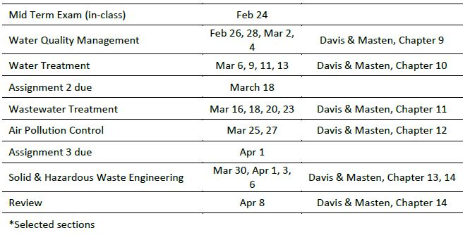

LAB CONTENT

